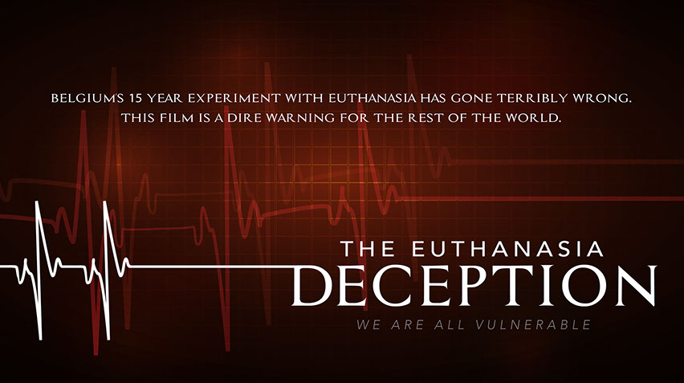
Shining the Light on Assisted Suicide: A Screening of the Euthanasia Deception
Join us as we watch, The Euthanasia Deception, a one-hour documentary featuring powerful testimonies from Belgium and beyond of lives devastated by the false ideology of ‘mercy killing’.

See first-hand about what happens when physician assisted suicide [euthanasia] becomes legal . . .a threat that Maryland has faced for the past three years.

Learn what you need to know to help prevent physician assisted suicide from being made legal and how you can prevent it from becoming a reality in Maryland.
EVENT INFORMATION

Date: Tuesday, September 26, 2017

Time: 7:00pm to 9:00pm

Location:
Frederick 1st Church of the Nazarene
7899 Opossumtown Pike
Frederick, Md. 21702

For more information please contact:
John Miller, johnm45@comcast.net;
240-446-8624

Hosted by the Maryland March for Life
www.mdmarchforlife.com

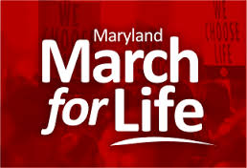

For additional details about the documentary, please visit vulnerablefilm.com or caringnotkilling.com.

